Sackville Heights Elementary School
GRADE 1 Classroom Supply List
2025-2026

Quantity | Item | Like This or Similar…
5 | Duotangs (1 blue, 1 green, 1 yellow, 1 red, 1 orange) | 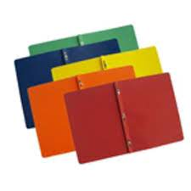
2 | Plastic pocket folders with prongs (1 red, 1 blue) | 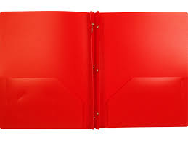
2 | Small green journals (½ page lined, ½ page blank) | 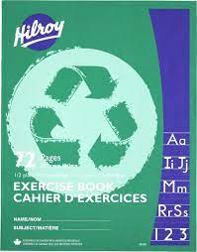
4 | White erasers | 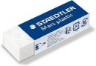
3 | Large glue sticks (40g) | 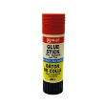
1 | Package of Play Doh (comes in a pack of 4 at Dollarama) | 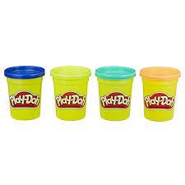
1 | Child size scissors (rounded tip) | 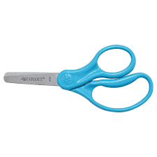
2 | Box of pre-sharpened pencils (12 pack, Staedler recommended by not required) | 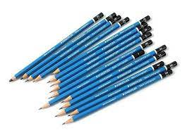
3 | Boxes of crayons (24 pack, Crayola recommended but not required) | 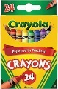
1 | Box wide washable markers (10 pack, Crayola recommended but not required) | 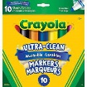
1 | Pencil box | 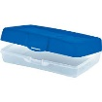
1 | Package 20 pack page protectors | 
1 | Message bags (zippered courier bag from the Dollar Store, 15”x10.2”) | 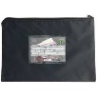
1 | Pair of labelled indoor running shoes to keep at school | 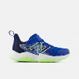
8 | Expo white board markers thin tip | 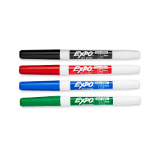
1 | Set of headphones (not earbuds as they get tangled, can get from Dollarama) | 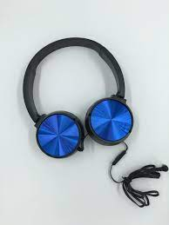

** Please note: the following items are not required but would be greatly appreciated donations:
- Kleenex
- Box of large ziplock bags

