Sackville Heights Elementary School
GRADE 2 Classroom Supply List
2025-2026

Quantity | Item | Like This or Similar…
5 | Duotangs (1 blue, 1 green, 1 yellow,  1 orange, 1 red) | 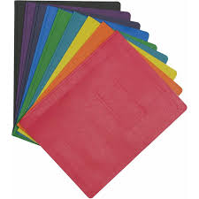
1 | Blue plain lined notebook | 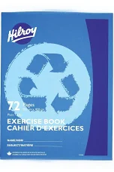
2 | Plastic pocket folder no prongs (1 red, 1 blue) | 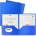
1 | Composition Notebook (Dollarama) | 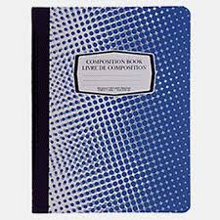
3 | White erasers
3 | Large glue sticks (40g) | 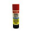
2 | Small yellow journals ½ lined, ½ blank | 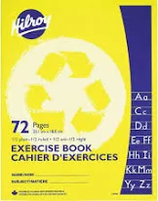
1 | Pair of good quality scissors
4 | Box of pre-sharpened pencils (12 pack, Staedler recommended by not required) | 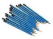
1 | Box of colored pencils (24 pack, Crayola recommended but not required) | 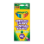
2 | Box wide washable markers (minimum 10 pack, Crayola recommended but not required) | 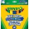
3 | Box crayons (24 pack, Crayola recommended but not required) | 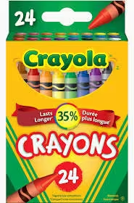
2 | Packages of high quality page protectors | 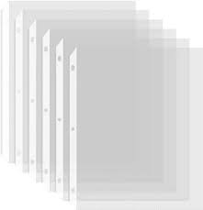
1 | Message bags (zippered courier bag from the Dollar Store, 15”x10.2” LARGE) | 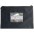
1 | Pair of labelled indoor running shoes to keep at school | 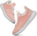
2 | Packages of white board markers | 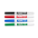
1 | Set of headphones or earbuds (can get from Dollarama) | 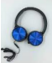
1 | Pencil sharpener that holds the shavings | 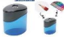
1 | Package of loose leaf paper, 500 sheets | 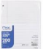
1 | Packages of Hilroy scribblers (4/pack, 32  pages) | 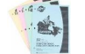
1 | Pencil Box | 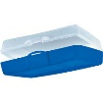

** Please note: the following items are not required but would be greatly appreciated donations:
- large ziploc bags

