Sackville Heights Elementary School
GRADE 3 Classroom Supply List
2025-2026

Quantity | Item | Like This or Similar…
7 | Duotangs ( 1 blue, 1 green, 1 yellow,  1 orange, 1 red, 1 black, 1 white) | 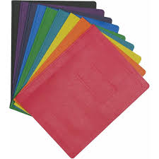
1 | Plastic pocket folders with prongs | 
1 | Plastic pocket folder no prongs | 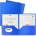
1 | Composition Notebook (Dollarama) | 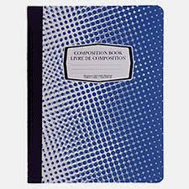
4 | White erasers
4 | Large glue sticks (40g)  Please label the stick AND the cap. | 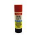
1 | Yellow highlighter | 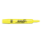
1 | Pair of good quality scissors
3 | Box of pre-sharpened pencils (12 pack, Staedler recommended by not required) | 
1 | Box of colored pencils (24 pack, Crayola recommended but not required) | 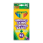
1 | Box wide washable markers (minimum 10 pack, Crayola recommended but not required) | 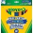
1 | Box crayons (24 pack, Crayola recommended but not required) | 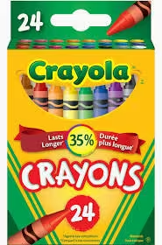
2 | Black Sharpie markers
1 | Message bags (zippered courier bag from the Dollar Store, 15”x10.2” LARGE) | 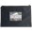
1 | Pair of labelled indoor running shoes to keep at school | 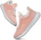
8 | Expo white board markers  4 thick and 4 thin | 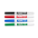
1 | Good quality white board eraser. | 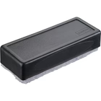
1 | Set of headphones or earbuds (can get from Dollarama) | 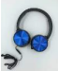
1 | Pencil sharpener that holds the shavings | 
1 | 30 cm ruler  If possible, please avoid rulers with inches.
1 | Package of loose leaf paper, 500 sheets | 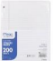
1 | Clipboard | 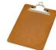
1 | Packages of Hilroy scribblers (4/pack, 32  pages) | 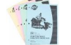
1 | Large Hilroy scrapbook | 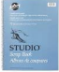

** Please note: the following items are not required but would be greatly appreciated donations:
- Box of tissues
- large ziploc bags
- baby wipes
- plastic page protectors

