Sackville Heights Elementary School
GRADE 4 Classroom Supply List
2025-2026

Quantity | Item | Like This or Similar…
4 | Duotangs ( 1 blue, 1 green, 1 yellow, 1 red,) | 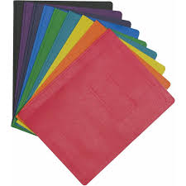
1 | Grid paper scribbler | 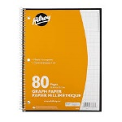
1 | Plastic pocket folder no prongs | 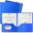
1 | Composition Notebook (Dollarama) | 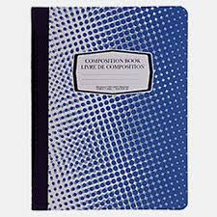
4 | White erasers
2 | Large glue sticks (40g) | 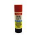
1 | Pencil Box | 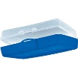
1 | Pair of good quality scissors
60 | Pre-sharpened pencils (12 pack, Staedler recommended by not required) | 
1 | Box of colored pencils (24 pack, Crayola recommended but not required) | 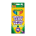
1 | Box wide washable markers (minimum 10 pack, Crayola recommended but not required) | 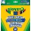
1 | 1 or 1.5” binder | 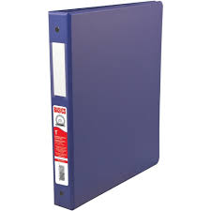
2 | Black Sharpie markers – 1 fine tip, 1 regular tip
1 | Page Dividers 6 pk or more (Dollar Store) | 
1 | Pair of labelled indoor running shoes to keep at school | 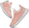
8 | Expo white board markers  4 thick and 4 thin | 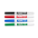
1 | Clean sock to be used for white board eraser | 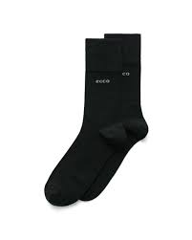
1 | Set of headphones or earbuds (can get from Dollarama) | 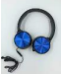
1 | Pencil sharpener that holds the shavings | 
1 | 30 cm ruler  If possible, please avoid rulers with inches.
1 | Package of loose leaf paper, 150 sheets | 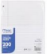
1 | Clipboard | 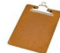
1 | Packages of Hilroy scribblers (4/pack, 80  pages) | 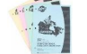
1 | Small whiteboard (Dollar Store) | 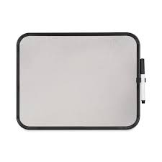
1 | Packages of high quality page protectors | 

** Please note: the following items are not required but would be greatly appreciated donations:
- Box of tissues
- Deck of cards for fact fluency

