Sackville Heights Elementary School
GRADE 5 Classroom Supply List
2025-2026

Quantity | Item | Like This or Similar…
6 | Duotangs: any colour | 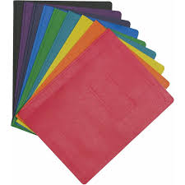
2 | Plastic pocket folder no prongs | 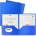
1 | Composition Notebook (Dollarama) | 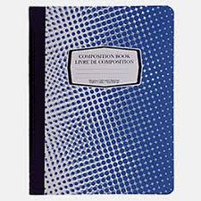
3 | White erasers
2 | Large glue sticks (40g) | 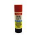
1 | Pencil Box | 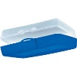
1 | Pair of good quality scissors
4 | Packages of 24 Pre-sharpened pencils (Staedler recommended by not required) | 
1 | Box of colored pencils (24 pack, Crayola recommended but not required) | 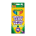
2 | Box wide washable markers (minimum 10 pack, Crayola recommended but not required) | 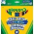
2 | Black Sharpie markers
1 | Pair of labelled indoor running shoes to keep at school | 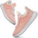
2 | Packages thin white board markers | 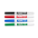
1 | Set of headphones or earbuds (can get from Dollarama) | 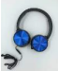
1 | Pencil sharpener that holds the shavings | 
1 | 30 cm ruler  If possible, please avoid rulers with inches.
1 | Package of loose leaf paper, 150 sheets | 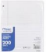
1 | Packages of Hilroy scribblers (4/pack, 80  Pages no coil) | 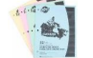
1 | Packages of post it flags (page markers) | 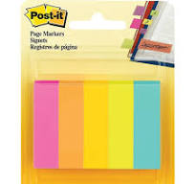

** Please note: the following items are not required but would be greatly appreciated donations:
- Box of tissues
- Pack of wet wipes

