Sackville Heights Elementary School
GRADE PRIMARY Classroom Supply List
2025-2026

Quantity | Item | Like This or  Similar…
1 | Pair of labelled indoor running shoes to keep at school: VELCRO CLOSURE | 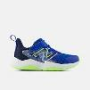
1 | Backpack large enough to fit message bag, extra clothes, snow pants and lunch bag
2 | Blue paper pocket folder (not a duotang) | 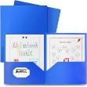
1 | White eraser | 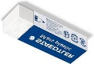
2 | Large glue sticks (40g) | 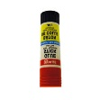
1 | White glue (120ml) | 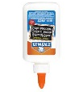
1 | Child size scissors (rounded tip) | 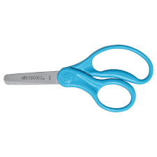
1 | Box of pre-sharpened pencils (12 pack, Staedler recommended by not required) | 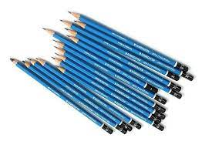
3 | Boxes of crayons (24 pack, Crayola recommended but not required) | 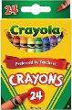
1 | Box wide washable markers (10 pack, Crayola recommended but not required) | 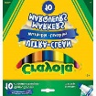
1 | Pencil box | 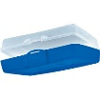
7 | Duotangs (2 red, 2 yellow, 1 orange, 1 green, 1 blue) | 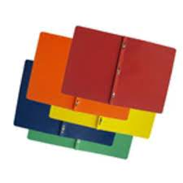
2 | Message bags (zippered courier bag from the Dollar Store, 15”x10.2”) | 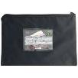
8 | Expo white board markers | 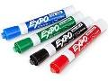
2 | Package Play Doh (comes in a pack of 4 at Dollarama) | 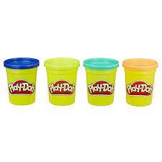
2 | ½ lined ½ blank scribbler | 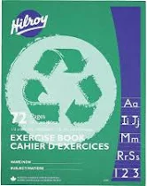

** Please note: the following items are not required but would be greatly appreciated donations:
- Kleenex
- Box of large ziplock bags

Please do NOT label supplies 🙂

